2.6 Planning Proposal Old Hospital Site

TRIM REFERENCE:

AUTHOR: Craig Mortell, Senior Planner

**EXECUTIVE Summary**

The former Orange Base Hospital site (bounded by Anson Street, Dalton Street, Sale Street and Prince Street) was zoned under the LEP as R3 Medium Density Residential, with building height limits and floor space controls intended to facilitate a successful redevelopment of the site.

Subsequently, a master planning exercise was conducted in 2012/13 to explore the potential of the site and articulate appropriate urban design outcomes. The preferred option of the master plan was a mix of adaptive re-use, residential, mixed use and recreation.

A number of master plan concepts were assessed, with the preferred option from the Health Infrastructure/Allen Jack+Cottier Architects (AJ+C) plan recommending splitting the zoning of the site into three areas. The western Sale Street end was recommended to provide a strip of RE1 Public Recreation zone to facilitate a park, the central area to remain R3 Medium Density Residential, and the eastern Anson Street end was recommended to become B4 Mixed Use to encourage the clustering of commercial activity into a coherent precinct.

Another master planning exercise was undertaken in 2016 by John Andrews, TAD Design and LADesign as part of packaging the prospectus of the site to prepare to go to Expression of Interest. This version considered placing an east-west corridor of open space through the middle of the site rather than a north-south strip. It augmented and built on the AJ+C masterplan completed by Health Infrastructure.

To meet the master plan requirements, an adjustment to the zoning is required.

More recently, the State government has announced that they are seeking an appropriate location within Orange to provide approximately 8,500m2 of office space for the Department of Primary Industries. Property NSW called for Expressions of Interest outlining a range of criteria that any successful site would need to provide. It is understood that a number of bids were lodged and are being evaluated by the State government.

One of the bids is from a developer that had made an unsolicited offer to Council, and upon which the parties have agreed to enter into an option agreement for a portion of the former base hospital site. To satisfy the Property NSW requirements, the site would require an adjustment to the current zones and height limits, the configuration of which differs from the Health Infrastructure/AJ+C plan – noting that retention of the main hospital building is no longer intended.

In order to proceed, a draft planning proposal has been prepared that seeks to rezone part of the site and amend building height limits to enable the master plan principles to be maintained toward the western end of the block, with the requirements of the bid to provide office premises for the DPI toward the eastern end of the block. Parkland is retained in a range of potential locations under the rezoning.

Due to both the capital investment value (CIV) of the possible DPI development being likely to well exceed $20m and the level of Council involvement, being current owners of the land, it is assumed that the Department of Planning and Environment (DPE) will not delegate the final decision to Council. Alternatively, Council could request determination by DPE in the event that DPE did not voluntarily decide to determine the rezoning. Furthermore, any subsequent DA for the DPI development would be determined by the Joint Regional Planning Panel, not Orange City Council, given the CIV level.

**Link To Delivery/OPerational Plan**

The recommendation in this report relates to the Delivery/Operational Plan strategy “1.2 Our City - Information and advice provided for the decision-making process will be succinct, reasoned, accurate, timely and balanced”.

**Financial Implications**

Nil

**Policy and Governance Implications**

Nil

*Do not delete this line*

|  |
| --- |
| **Recommendation**  **1 That staff prepare a planning proposal comprising draft height of building and land use zone maps that would zone the eastern side of the site as B4 Mixed Use.**  **2 That the draft planning proposal retain the western side of the site as R3 Medium Density Residential and RE1 Public Recreation zone.**  **3 That Council forward the planning proposal to the Department of Planning and Environment to seek a Gateway determination.**  **4 That subject to any conditions of a Gateway determination, the matter be placed on public exhibition for a period of 28 days.** |

*Do not delete this line*

**further considerations**

Consideration has been given to the recommendation’s impact on Council’s service delivery; image and reputation; political; environmental; health and safety; employees; stakeholders and project management; and no further implications or risks have been identified.

**SUPPORTING INFORMATION**

Following the opening of the new Health Service on Forest Road, the former Orange Base Hospital site bounded by Dalton Street, Anson Street, Prince Street and Sale Street was closed and has remained vacant pending its demolition and ultimate redevelopment.

With an area of approximately 2 hectares and full street frontages to all sides, the site presents a unique opportunity in central Orange – further enhanced by the relationship to various surrounding land uses, such as the TAFE campus to the south and a variety of adjoining mixed uses including a number of medical and ancillary consulting rooms and community health uses.

Recognising the significance of the site Council acquired it from the State Government to facilitate redevelopment and ensure the community would have an influence over the future of this site. A master plan was developed by Health Infrastructure to showcase the potential of the site for a range of uses, showcasing a number of development options.

The master plan was presented to Council as part of the acquisition. Council was briefed on the matter on several occasions, with the consultancy who prepared the master plan giving a full presentation to Council to inform Council’s decision for the acquisition. Councillors have been provided with a masterplan summary document (given the size of the full document) and this document has been publicly available, provided to members of the public and has appeared in numerous media articles.

The conceptual vision in the master plan was not linked to a firm proposal, but instead intended to demonstrate the potential of the site. The master plan requires an amendment to the Local Environmental Plan to confirm the uses, height limits and floor space ratio.

Council’s promotion of its activities on the site, including the recent site demolition development application, has attracted early interest in the site.

The purpose of this report is to initiate the investigation and preparatory documents so that Council can progress a partial mixed use zone for the site as well as other appropriate zonings including medium density residential and recreation/open space. The conditional unsolicited offer warrants exploration in the opinion of the author of this report.

The objectives of this planning proposal are:

* To provide for a mixed range of education, administration, office and business premises with supporting retail and open space areas in addition to residential accommodation.
* To amend the land zoning map to provide for mixed use development on the site of the former base hospital.
* To amend the height of buildings map to provide flexibility in the placement of building forms and densities on the site of the former base hospital.
* To amend the floor space ratio map to provide flexibility in the location and siting of built form on the site of the former base hospital.

The following images provide an overview of the current and proposed height limits and land use zones, and illustrate the potential relationship between a public administration building with medium density residential development. These are conceptual designs only that have been explored to ensure that height limits and zone boundaries are established that can allow sufficient flexibility at the Development Application stage while seeking to retain the mix of uses and densities established under the master plan.

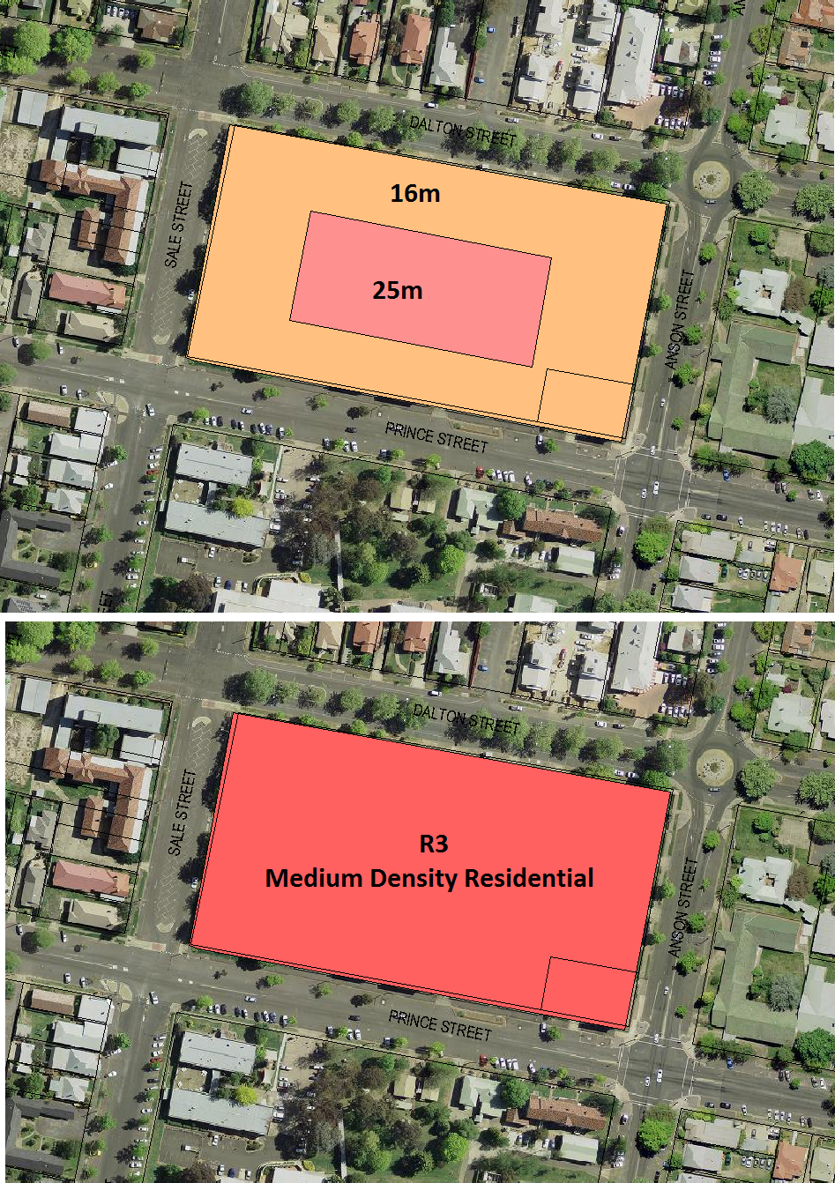

**The current height limits and land use zone for the old hospital site**

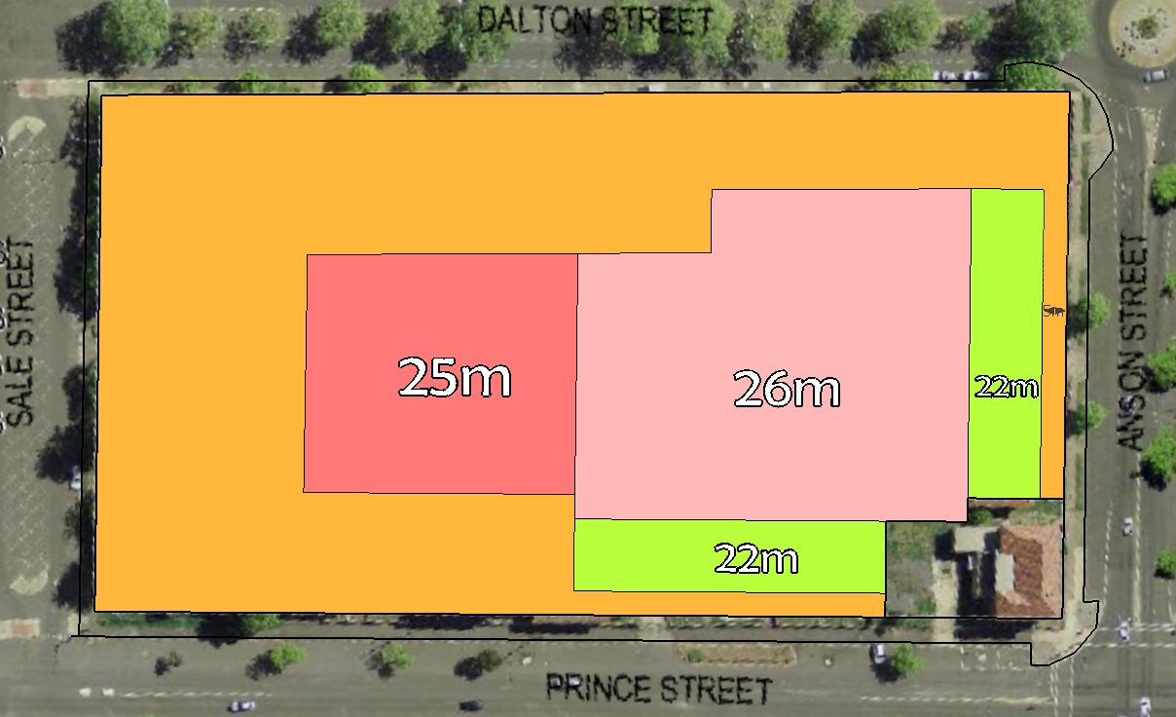

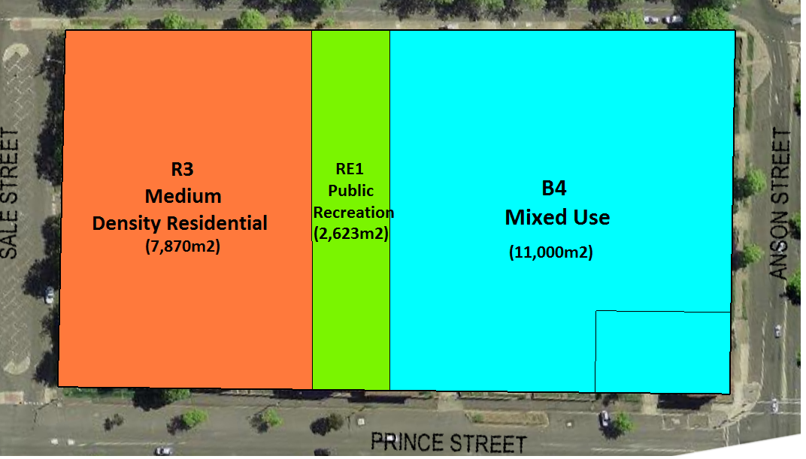**The Proposed height limits and land use zones for the hospital site**

**Zoning pattern consistent with a modified version of the Health Infrastructure KJC master plan**

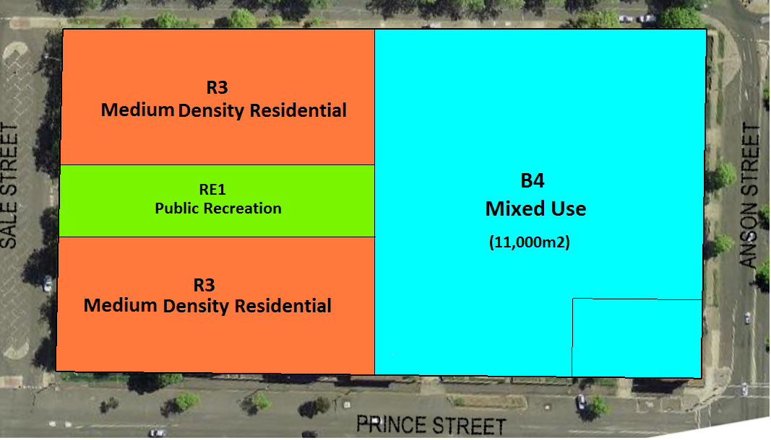

**An alternative zoning pattern consistent with a modified version of the master plan**

**to enhance the development of the site**

Due to the desire to provide flexibility in responding to the Property NSW EOI process, the areas shown are approximations only, intended to illustrate the concept for the site and gauge community reaction. Final dimensions and areas will be confirmed following public exhibition. This will enable community consultation and development needs to be evaluated in tandem. The intent is to balance R3 (Medium Density Residential) land use and enable a successful B4 (Mixed Use) land use (including car park, retention of ambulance station and use of a public park).

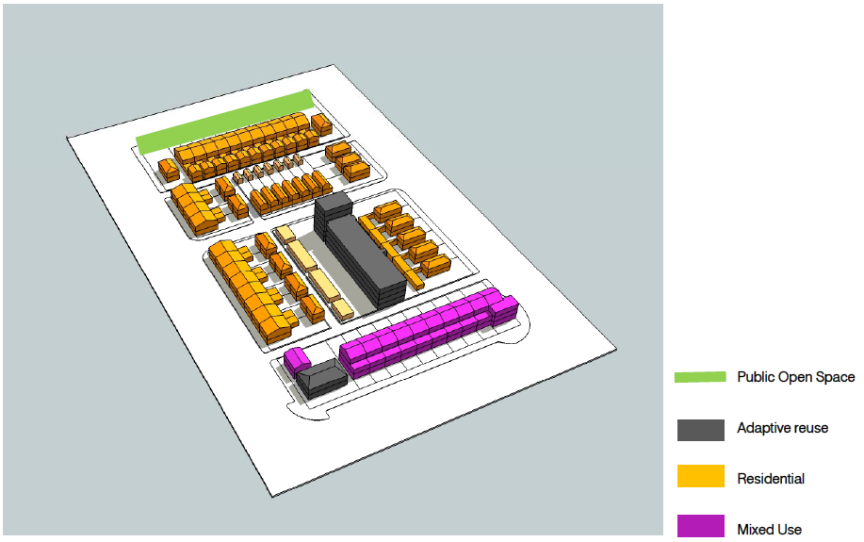

**The concept from the Health Infrastructure/AJ+C master planning exercise of 2012/13**

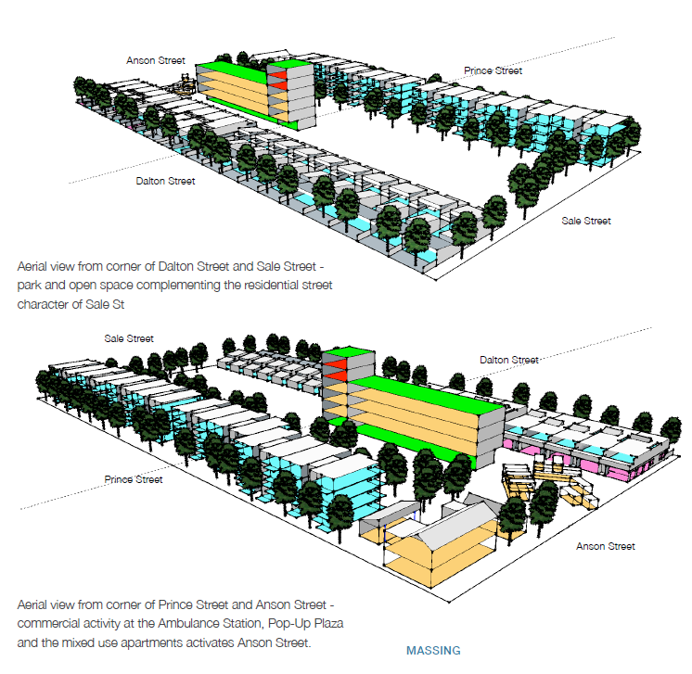

**An enhancement of the master plan as commissioned by Council**

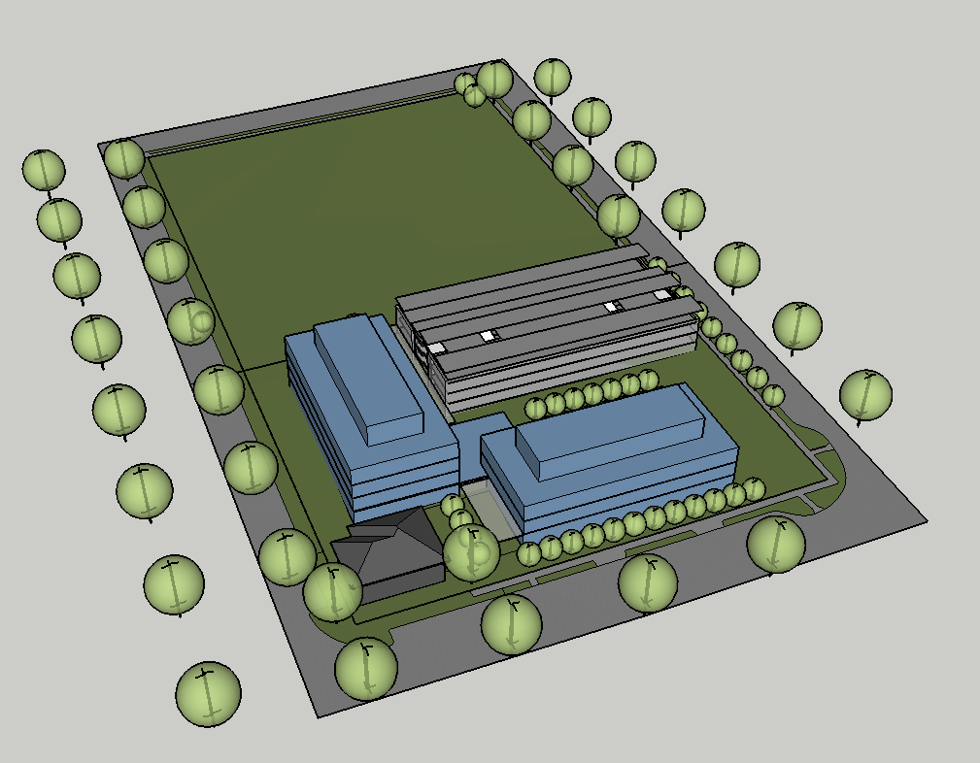

**A conceptual model approximating the main structural elements of a public administration**

**building and multi-deck car park consistent with the State Government requirements for**

**new DPI headquarters.**

**(note retention of the heritage listed Ambulance building on the Prince and**

**Anson Streets intersection.**

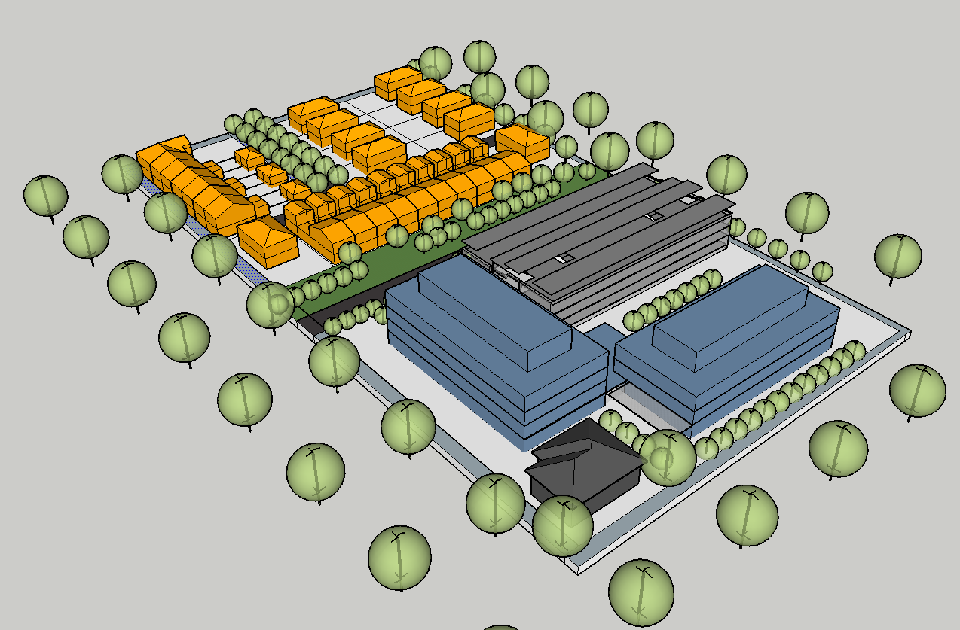

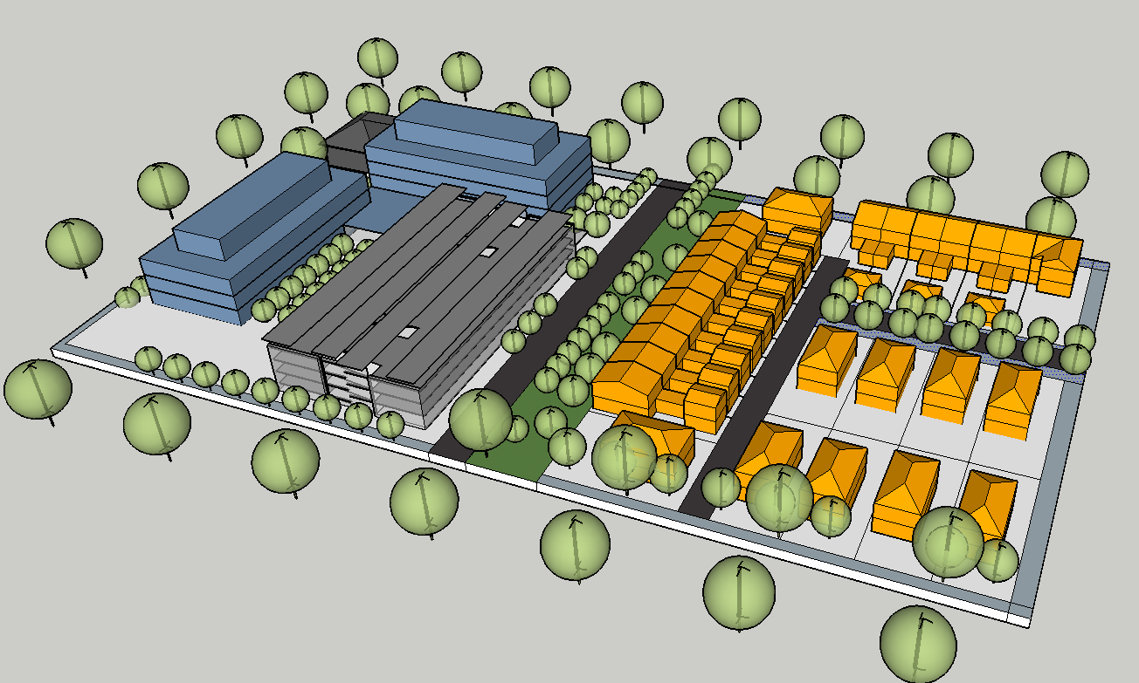

**Conceptual models illustrating options to combine the master plan and DPI headquarters**

*Do not delete this line*

**Attachments**

1 Preliminary draft planning proposal to rezone and amend height limts, D17/32051